

Nuclear Fusion of D2O in a Pulse Heated Uniaxial Anvil Cell

BY Michael Lynn



April 25, 2022

1764 N. Leverett Avenue, Fayetteville AR.

# TLDR;

The conventional primary figure of merit for fusion ignition and breakeven performance is the Lawson criterion. Conventional fusion approaches have largely failed to obtain the Lawson criterion, and even when they have, they have done so at great expense of time, money and energy, such that no breakeven power production, the primary aim of fusion research, can be realized. It can be demonstrated that a bench scale CVD diamond coated tungsten carbide anvil cell system, loaded with D2O compressed to the Ice VII state, and heated by high voltage pulse power, as in the operation of a high voltage power capacitor or Zener diode can exceed the temperature, number density and confinement time of the conventionally defined Lawson criterion for nuclear fusion ignition by ~6 orders of magnitude. This, together with a relatively simple and highly efficient mechanism for extracting power from the fusion reactions via electromagnetic direct energy extraction and subsequent buck conversion of the resultant waveform, in addition to a continuous liquid cooling loop, could enable a new generation of bench scale energy generating devices, using a commercially accessible and abundant fuel source in a simple to construct and extremely affordable form factor with no moving parts and with operational safety comparable to a conventional generator, or solar PV system.

# Introduction and Scope of This Document

Herein we will reference a variety of prior work in the field of nuclear fusion, high pressure physics, planetary science and power electronics to pull together the features of our new approach to net fusion power on the home desktop. This document will be written with the technical, but not specialist reader in mind, thus, if you need further reading, most of the terms herein can be found on Wikipedia with good accuracy, and beyond that, the conventional research literature has a wide variety of high quality reviews for the less technical reader.

First, we will discuss a brief review of what the conditions for fusion are, how they are conventionally achieved, and why our anvil cell system should work given the existing well established criteria for successful ignition of fusion reactions, and for net power extraction therefrom.

Next, we will describe the specific operational elements of our system, and how each of them allows access to a specific parameter regime in which the Lawson criterion can be realized for a small sample with high energy extraction efficiency and with a usefully large reaction rate.

Finally we will discuss the logistical and economic aspects of building this system and what the probable challenges are in making it work, and work well.

# Why This Should Work

From first principles, fusion is very simple, it is a process where, under sufficient temperature and pressure, for a sufficient time over a sufficiently large volume, lighter nuclei combine to form more massive nuclei. In conventional fusion research this simple relationship is summed up in the Lawson criterion[1], or more generally as the Lawson triple product. It is expressed typically as the multiple of the number density of fuel nuclei, per meter cubed, with the gaussian average temperature of those fuel nuclei in KeV (or Kelvin) multiplied by the time for which the two foregoing values are maintained. Expressed succinctly in equation 1.

Where is short for Lawson criterion triple product, is the number density of fuel nuclei, is the gaussian average temperature of those nuclei, and is the confinement time of the reactants in a fusion system, with respect to the forgoing parameters.

In conventional fusion approaches, particularly those involving gaseous plasmas, fusion yield is limited by all three factors. Plasma’s starting as a tenuous gas, constrained by even the most powerful (and wibbily wobbly) electromagnetic fields, have been shown, thus far, to be limited to or so. This wall of exponential difficulty arises from a variety of confounding physical complexities largely to do with the physical implementation of the existing approaches. If one examines the maximal number density attained in gas phase plasma systems, and compares their number densities, , to the number density of common water at STP(roughly 3.34), one quickly discovers the first big problem for conventional fusion systems…*gases are inherently non dense*. This problem only worsens when we introduce ionization to the gas molecules, which would then consequently be repelled from one another by their mutual charges, and, if charged and in a magnetic field, as per a tokamak configuration, they tend to spiral wildly and lose energy to synchrotron radiation, and ultimately spiral right into the walls of our container! Further, the maximum effective pressure a Tokamak primary field coil can sustain in the modern day, is approximately 1-2 atmospheres or ~100 KPa. Consequently, in the quest for breakeven power, conventional fusion approaches attempt to make up for the lack of number density by greatly raising the ion temperature, to ~200 KeV, and confinement time to order of seconds, which necessitates still bigger magnetic and electric fields, and still more input power given their huge volumes and the scaling of energy loss through radiation. This approach, has thus far failed to produce more electrical power than it consumes, and has, power not withstanding, cost a great deal of time and resources, largely to no net effect on realizing actual benefits of fusion power for the home user. However, there is something critical to be learned from conventional fusion approaches, that temperature, pressure, and confinement time play roughly equal roles in generating net gain of fusion power from any given reaction of interest in any reactor geometry. As we shall see later, this simple fact is the key to the potential of our described anvil cell fusion technology.

In nature, from what we know of the mechanisms driving the sun, number density, confinement time, and the right amount of heat for the reaction of interest are how the sun generates its energy. Under a truly enormous internal pressure, 26.5 PPa, an effective density of 150 grams per cubic centimeter(a mere 150 times the density of water at STP), and at an average temperature of 15 KeV, with a confinement time measured in eons, the sun does it’s fusion through compression, and time, with lots of help from quantum tunneling effects at degeneracy inducing pressures. Of course, the sun is not the only warm body to which we might look for inspiration on how to do fusion here in the lab. In recent times, considerations of the earth, its’ excess surface heat load, anomalous emissions of helium 4 from the crust, and neutrino emissions from the deep core, have potentially given us a new picture of how our planet remains tectonically and magnetically active, even while its less dense neighbors, Venus, and Mars have long since gone dormant.[2,3] This discovery, and similar such mechanisms in other pressurized and deuterated media[4,5] have been gaining traction as an explanation for the excess radius of Saturn, and Jupiter, and of particular interest to us, the relative warmth of Neptune, as compared to other outer worlds(Uranus), far out in the solar system. [6] In the case of the planets, in particular earth and Neptune, the pressures at their cores have been estimated to be 360 and 760 GPa, respectively, at temperatures of ~5500 and 6700 K. If we apply the Lawson triple product calculation using these values, as is done, with deep respect to the quantum details relevant to the earth core system, in [2,3,5], we find that the energy output is small, but amounts to a large ultimate value(~100 TW total) due to the volume of the earth’s core, or that of Neptune respectively (if we assume some similar process is occurring there). In essence, the Earth’s core meets the Lawson criterion, even at a tiny fraction of the temperature and pressure attained by the sun! simply by an incidentally strategic balance of material composition, and presumably, deuterium content. Under the conditions in the earths core, which are far less energetic than those of the sun, the reaction rate is terribly low, a mere generating power of roughly, , as compared to the sun’s ~240 W/ but over a large volume of material, this value adds up. Nonetheless, the earth would seem to be doing fusion at its core, even with an abundance of passive heavy elements such as nickel and iron involved, acting primarily as molecular compressors and suppliers of screening electrons, and as confinement aids for the deuterium at the low temperatures and pressures available to a planet the size of the earth. Given the earth’s solid state conditions of fusion, at relatively low temperatures and pressures compared to the sun, and from what we know of lattice confined fusion reactions in deuterated materials it stands to reason, that such a mechanism could be exploited for net power generation at a useful rate, if only there were some way to improve it’s efficiency, by making the confining lattice atoms participate in the reaction, as well as provide screening potentials to increase the fusion cross section of the involved fuels, while simultaneously raising the temperature of the fusion fuel… Indeed, in [2,4], the specific physics of how the cross section of relevant fusion reactions changes given the lattice confinement conditions, and the dependence of the reaction rate on temperature is discussed… generally, under the conditions in deuterated metals, an increase in reaction cross section of some 50% for D-D fusion in erbium lattices has been shown, while, the reaction rate posited in [2,3] depends on the temperature of the lattice (alternatively the temperature of the fuel) approximately exponentially, that is . This would indicate that fusion, is subject to catalysis at modest temperatures, and modest pressures available to humans, in well chosen systems…

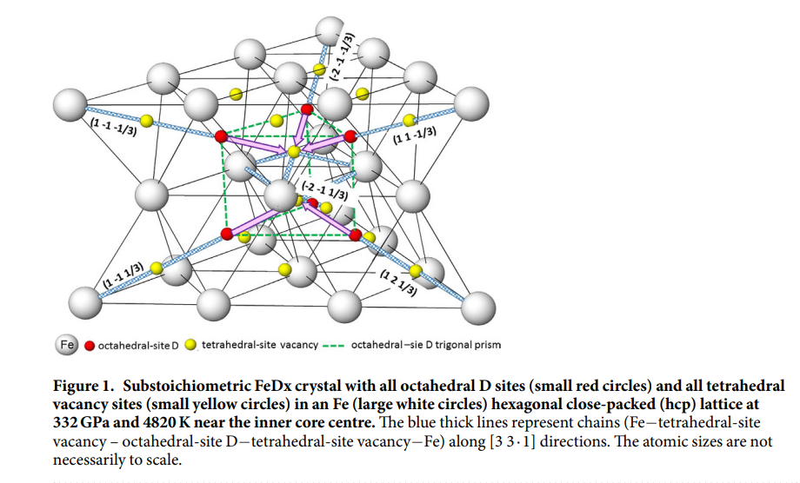

Figure 1. a figure from Fukuhara, describing iron deuteride lattice confinement effects at the earth's core.

On a related note, the sun, gets its energy from two fusion cycles, primarily(98.4%) from the proton-proton chain, while the remainder appears to originate from the CNO, or carbon nitrogen and oxygen catalytic fusion cycle[7,8]. The CNO cycle is far more temperature dependent as shown in figure(2) and does not normally occur in conventional fusion approaches, due to the exclusive use of light fusion fuels such as deuterium, tritium and helium. However, if catalytic fusion can occur in lattice confined systems at modest pressures and temperatures, in the laboratory,[4], and in the core of a relatively small planet like the earth, [3], it stands to reason that similar such reactions might occur in other lattices, in other planets with much higher reaction efficiencies per unit temperature at the core, for example, inside Neptune. An Ice giant, is generally deplete in heavier elements, with atmospheres and presumably cores that consist primarily of water ice, at high pressure, as well as ammonia, methane and other light gaseous products. [6,9,10] Neptune in particular, is a warm and violent ice giant, with massive storms, and the fastest winds in the solar system(exceeding 1200 mph by some estimates), despite being much smaller than Jupiter or Saturn (by fact 5-10X) and much farther from the sun, with only 1/900th as much sunlight. Bizarrely, Neptune emits almost 2.6 times as much energy from it’s surface, as it receives, from the sun, more than twice that of Uranus. Something inside Neptune [11], must be contributing the enormous energy to drive it’s surface weather, and its relative illuminance compared to the other, outer planets. Seeing as it’s estimated core pressures and temperatures are only slightly above earth’s, considering the huge disparity in size, Neptune is not particularly dense. Most likely it has a great deal of ice near it’s core, dense ice, perhaps ice VII or Ice X. Further, it is possible, that over many eons, Neptune has agglomerated and distilled through gravitational effects, very similar to those described in [2], deuterated compounds, like D2O, methane, ammonia, and others. Making it a place, of high pressure, high temperature, and rich in CNO catalytic nuclear fuels with a relatively large cross section and comparatively modest coulomb barrier. Perhaps, Neptune gets its tremendous internal energy from dense ice lattice catalyzed D-D, D-O and subsequent D-CNO fusion, benefiting from relatively long mean free paths, hydrogen degeneracy in the oxygen lattice of dense ice phases, and the subsequent potential for large ion temperatures relative to the lattice temperature due to the position of the hydrogens as primary charge carriers, similar to the disparity in temperature of electrons and lattice in other semiconductors subject to high electric fields and elevated temperatures…[10,12–15]

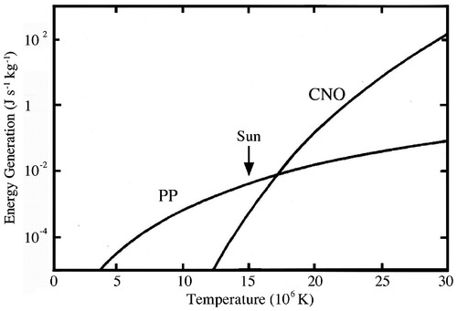

Figure 2. A figure from NASA depicting the differing temperature dependence of the CNO and Proton proton cycles, with respect to the sun's estimated core temperature.

The dense deuterated ices that may be responsible for the catalysis of CNO fusion at Neptune’s core , are fascinating materials, and unique in many ways. Ice VII, the densest form of ice, which generally forms at room temperature at a pressure of ~5 GPa, has a density of ~1.6 – 1.9 g/cc. This phase is potentially stable up to 100 GPa, at which point Ice X forms. [9,10]. Ice VII, is also the most electrically (semi)conductive (minimum resistivity at ~10-12 GPa at room temperature, of order 1E6 Ohm*m) form of ice, primarily conducting via the lattice hoping motion of hydrogen atoms(or Deuterium) dissolved in a fermi sea of pressure degenerated electrons[12,13]. This hydrogen lattice hoping behavior is essentially identical to the screening and compression lattice catalysis described in [2–5,16,17]. Further, given that the hydrogen becomes the primary charge carrier, it becomes subject to the largest velocities and accelerations(and thus highest effective temperatures) under applied electric fields before the rest of the lattice begins to respond, much as electrons in conventional semiconductors, or oxygen in high temperature ionic conductors such as zirconia do. [15]. It stands to reason, that a very high charge carrier temperature may correspond to a proportionately low lattice temperature, as seen in [15–17] given a sufficiently large applied electric field and hydrogen(Deuterium) ions sufficiently freed by pressure degeneracy in a dense ice phase. Thus, we have the potential to setup the conditions of D-D fusion, and given sufficient carrier temperatures by the application of a large electric field to a semiconducting dense deuterated ice phase, the potential for CNO fusion of Deuterium. Returning to our discussion of the Lawson triple product, the effective number density of Deuterium in such a dense ice would be of order ) Further, because there are essentially two fuel nuclei (D) per D2O molecule, there is twice that again in viable fuel, thus the actual number density of fuel nuclei, assuming no CNO fusion takes place would be )…if D-O fusion and subsequent CNO fusion begins at the temperatures and pressures we could achieve, our number density increases potentially to ). Thusly we have already got a big head start on conventional fusion approaches!

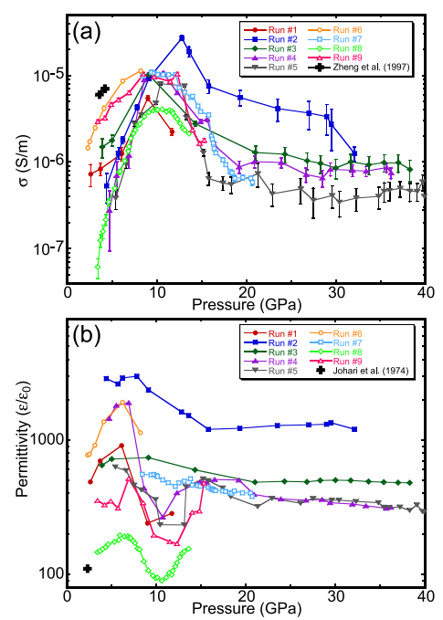

Figure 3. Pressure V conductivity and Pressure V Permittivity for ICE VII.

Now if only we could attain the temperatures for fusion of these thusly degenerated, densely packed freely flowing and coulomb screened deuterium charge carriers!

It is a well-known fact in electrical engineering that capacitors leak charge and contain large electric fields. In fact, it is a large point of research to increase the fields sustainable by capacitors for power electronic systems. Some such systems, in the modern day made by CREE and others can attain field strengths internally of ~30 MV/cm, with modest or negligible leakage rates. Such a field applied to our deuterium charge carriers in our dense ice VII lattice would generate a fuel temperature of 30 MeV given an accelerating distance of 1 cm. less, given smaller distances. If we compare that figure to the 15 KeV temperatures present in the core of the sun, or even the 200 KeV of ITER, the relative ease of generating large carrier ion temperatures inside a solid state system using off the shelf technology begins to appear feasible. Further, even if we reduce the accelerating distance to ~ 100 micron, we find that the potential ion temperatures remain quite high at some ~300 KeV. If we could just find a way to build a capacitor that could stably contain deuterated Ice VII we would have all three elements of the Lawson criterion down pat and the perfect recipe for a compact, solid state, low cost fusion reactor using abundant and available fuel and materials, to generate tremendous power per unit volume for extended periods of time!

To demonstrate this, the Lawson criterion is restated for reference below:

Where is short for Lawson criterion triple product, is the number density of fuel nuclei, is the gaussian average temperature of those nuclei, and is the confinement time of the reactants in a fusion system, with respect to the forgoing parameters.

Assuming we operate at the stable pressure of Ice VII at from room temperature to 1000K, which is approximately, 20 GPa, which corresponds to a density of 1.9g/cc, then our number density from earlier is , while our , given the effective fuel ion temperature attainable in a solid state lattice for hydrogen charge carriers free to move in the fermi sea under the influence of our 40 MV/cm, or 4 KV/micrometer, electric field would be ~300 KeV. If we assume a standard capacitor operating frequency on the low end of what is available off the shelf at 1KHz, that would correspond to a confinement time of 1 millisecond, or 0.001 seconds. Thus equation 1 becomes:

This is 7 orders of magnitude beyond the typical Lawson criterion value for fusion ignition. If we could only make and sustain such pressure!

Enter the anvil cell. A compact, relatively affordable, and easy to build device for generating and sustaining extreme pressures up to 1 TPa! By using simple 1/A dependence of pressure to multiply applied force into a small sample volume uniaxially; the diamond anvil cell or (DAC) for short, provides the experimenter the ability to generate pressure comparable to those at the center of the earth, or even the outer planets and probe the sample between the anvils with a laser or other optical tool. Some lower cost cells use silicon carbide or tungsten carbide anvils,[18–20] and there are examples of electrically insulating gaskets [12], made of Alumina, boron nitride and aluminum nitride. Conveniently, the DAC, or perhaps a version with a CVD diamond coated tungsten carbide anvil set would strongly resemble existing diamond capacitor technology (the ones with the 30MV/cm capability from earlier). It’s a match made in the heavens. By placing our common deuterium oxide, purchased from any chemical supplier or simply distilled from sea water, inside our electrically insulated diamond anvil cell capacitor, we could potentially attain the conditions for a 7 order of magnitude improvement over existing fusion approaches in terms of total temperature, confinement, and number density of fuel!

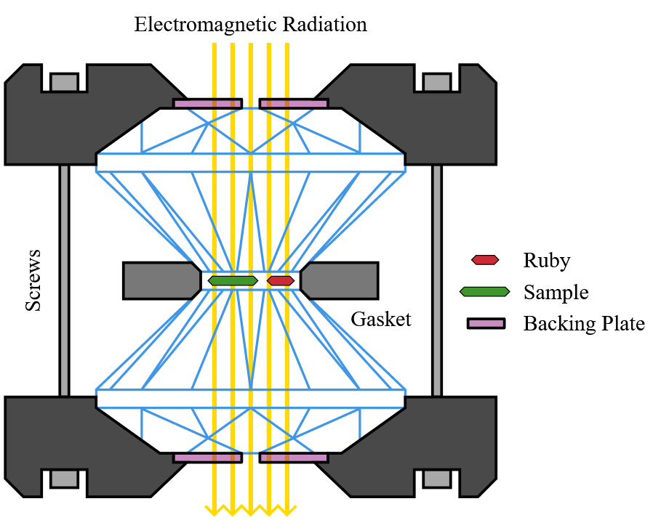

Figure 4. A representative cartoon of a diamond anvil cell from wikipedia.

In short, we are taking advantage of deuterium behaving as the primary charge carrier in an ionic semiconductor under high pressure in a intrinsically number dense environment, to generate D-D fusion via a large applied electric field and the subsequent generation of hot carriers in the lattice of the ionic conductor. A simple(less than scientific) way to check the potential practicality of such an approach would be to refer back to the calculated power generation value and general temperature dependence of the proposed fusion rate in iron hydrides in earth’s core.[2,3]. Iron hydride reaction rates under earth core conditions would represent a worst case scenario, due to the low temperatures involved and the large Z of the nonparticipating nuclei interfering with the transmission of reaction products to other fuel nuclei. In any case, the value given with dependence, for the reaction rate in the Earth’s core, where the specific relationship from the paper is given in equation 2,

was , where the , is reaction rate at room temperature ~300 K, and the fusion rate can be effectively multiplied by raising the temperature according to the foregoing relation, and if we insert our capacitor generated ion temperature of ~300 KeV, for instead of the 5770K off the earth’s core , and where E is the Boltzmann constant and R is the ideal gas constant,

Assuming the energy of the D-D reaction is 21.6 MeV total per complete reaction we find the total energy release rate per meter cubed to be:

This is a modest rate per unit volume, however, given that the static pressures of interest (10-100 GPa) can be generated with no continuous power input in existing cells of large sizes on the order of 100,000 cubic millimeters(1E-4 cubic meters), it represents a conservative start to a net fusion energy generation system. Under the assumption of maximum cell volume, at a pressure of 12 GPa, a power output of ~30 watts could be expected from our 1E-4 m cubed cell. If we use our previous number density to calculate the available fuel species, we find that there are ~1.2E25 fuel nuclei in the 1e-4 meter cubed cell volume, which, if burned at the above rate, in single step fusion reactions, we find the burn time, would be ~ 136116152 seconds, or, more reasonably stated, ~4 years. This is a conservative estimate of power output based on a modest pressure in a large volume cell. Further, given the high temperatures attainable by our ions in our anvil cell capacitor, and the availability of oxygen as a catalyst in our cell, there is a high probability of D-D fusion, but also the much more energy dense (by 3 orders of magnitude) CNO cycle, thus, if we assume the balance(>90%) of reactions at our operating temperature are actually CNO reactions, we could expect ~1000 times more output power per cubic meter! That is, conservatively from the first phase CNO reactions alone, . Now that is more like it! Even for a conservative cell volume of 2.3E-5 cubic meters, that represents ~7 kilowatts of continuous power output for a cell of readily available dimensions and made of commercial off the shelf materials. Of course, such large volume cells are proportionately more expensive and ultimately limited in the pressures they can generate. They are also more difficult to construct for the home user than a simple uniaxial press. Thus, it is of interest to run these same calculations under assumptions consistent with what is available to the home user, namely cell volumes not to exceed 7.9e-11 cubic meters, and under the same conservative energy generating assumptions as above. In this case, even assuming net CNO reactions in the cell at the same conservative 12 GPa pressure, we would expect a gross power output of 0.024 Watts continuous.

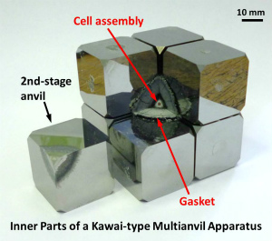

Figure 5. Kawaii Type multi anvil cell apparatus for large volume experiments up to ~100 GPa in large volumes.

# How This Could Work

# How We Will Make It Work

# Conclusion

# References

[1] Lawson, J. D., 1957, “Some Criteria for a Power Producing Thermonuclear Reactor,” Proc. Phys. Soc. Sect. B, **70**(1), pp. 6–10.

[2] Fukuhara, M., 2020, “Possible Nuclear Fusion of Deuteron in the Cores of Earth, Jupiter, Saturn, and Brown Dwarfs,” AIP Adv., **10**(3), p. 035126.

[3] Fukuhara, M., 2016, “Possible Generation of Heat from Nuclear Fusion in Earth’s Inner Core,” Sci. Rep., **6**(1), p. 37740.

[4] Pines, V., Pines, M., Chait, A., Steinetz, B. M., Forsley, L. P., Hendricks, R. C., Fralick, G. C., Benyo, T. L., Baramsai, B., Ugorowski, P. B., Becks, M. D., Martin, R. E., Penney, N., and Sandifer, C. E., 2020, “Nuclear Fusion Reactions in Deuterated Metals,” Phys. Rev. C, **101**(4), p. 044609.

[5] Terez, E. I., and Terez, I. E., 2015, “Fusion Reactions as the Main Source of the Earth’s Internal Energy,” Her. Russ. Acad. Sci., **85**(2), pp. 163–169.

[6] Chau, R., Hamel, S., and Nellis, W. J., 2011, “Chemical Processes in the Deep Interior of Uranus,” Nat. Commun., **2**(1), p. 203.

[7] Robitaille, P.-M., 2013, “The Liquid Metallic Hydrogen Model of the Sun and the Solar Atmosphere VII. Further Insights into the Chromosphere and Corona,” Prog. Phys., **3**, p. 7.

[8] Adelberger, E. G., García, A., Robertson, R. G. H., Snover, K. A., Balantekin, A. B., Heeger, K., Ramsey-Musolf, M. J., Bemmerer, D., Junghans, A., Bertulani, C. A., Chen, J.-W., Costantini, H., Prati, P., Couder, M., Uberseder, E., Wiescher, M., Cyburt, R., Davids, B., Freedman, S. J., Gai, M., Gazit, D., Gialanella, L., Imbriani, G., Greife, U., Hass, M., Haxton, W. C., Itahashi, T., Kubodera, K., Langanke, K., Leitner, D., Leitner, M., Vetter, P., Winslow, L., Marcucci, L. E., Motobayashi, T., Mukhamedzhanov, A., Tribble, R. E., Nollett, K. M., Nunes, F. M., Park, T.-S., Parker, P. D., Schiavilla, R., Simpson, E. C., Spitaleri, C., Strieder, F., Trautvetter, H.-P., Suemmerer, K., and Typel, S., 2011, “Solar Fusion Cross Sections. II. The p p Chain and CNO Cycles,” Rev. Mod. Phys., **83**(1), pp. 195–245.

[9] Hansen, T. C., 2021, “The Everlasting Hunt for New Ice Phases,” Nat. Commun., **12**(1), p. 3161.

[10] Wang, Y., Liu, H., Lv, J., Zhu, L., Wang, H., and Ma, Y., 2011, “High Pressure Partially Ionic Phase of Water Ice,” Nat. Commun., **2**(1), p. 563.

[11] Falk, K., 2018, “Experimental Methods for Warm Dense Matter Research,” High Power Laser Sci. Eng., **6**, p. e59.

[12] Okada, T., Iitaka, T., Yagi, T., and Aoki, K., 2015, “Electrical Conductivity of Ice VII,” Sci. Rep., **4**(1), p. 5778.

[13] Johari, G. P., Lavergne, A., and Whalley, E., 1974, “Dielectric Properties of Ice VII and VIII and the Phase Boundary between Ice VI and VII,” J. Chem. Phys., **61**(10), pp. 4292–4300.

[14] Myint, P. C., Benedict, L. X., and Belof, J. L., 2017, “Free Energy Models for Ice VII and Liquid Water Derived from Pressure, Entropy, and Heat Capacity Relations,” J. Chem. Phys., **147**(8), p. 084505.

[15] Yang, L., Qian, R. J., An, Z. H., Komiyama, S., and Lu, W., 2019, “Simulation of Temperature Profile for the Electron and the Lattice Systems in Laterally Structured Layered Conductors,” EPL Europhys. Lett., **128**(1), p. 17001.

[16] Steinetz, B. M., Benyo, T. L., Pines, V., Pines, M., Consulting, P., Forsley, L. P., Corporation, J., Westmeyer, P. A., Chait, A., Becks, M. D., Martin, R. E., Hendricks, R. C., Penney, N., Marsolais, A. M., and Kamm, T. R., 2017, “Experimental Observations of Nuclear Activity in Deuterated Materials Subjected to a Low-Energy Photon Beam,” p. 32.

[17] Steinetz, B. M., Benyo, T. L., Chait, A., Hendricks, R. C., Forsley, L. P., Baramsai, B., Ugorowski, P. B., Becks, M. D., Pines, V., Pines, M., Martin, R. E., Penney, N., Fralick, G. C., and Sandifer, C. E., 2020, “Novel Nuclear Reactions Observed in Bremsstrahlung-Irradiated Deuterated Metals,” Phys. Rev. C, **101**(4), p. 044610.

[18] Gavriliuk, A. G., Mironovich, A. A., and Struzhkin, V. V., 2009, “Miniature Diamond Anvil Cell for Broad Range of High Pressure Measurements,” Rev. Sci. Instrum., **80**(4), p. 043906.

[19] Sterer, E., Pasternak, M. P., and Taylor, R. D., 1990, “A Multipurpose Miniature Diamond Anvil Cell,” Rev. Sci. Instrum., **61**(3), pp. 1117–1119.

[20] Anzellini, S., and Boccato, S., 2020, “A Practical Review of the Laser-Heated Diamond Anvil Cell for University Laboratories and Synchrotron Applications,” Crystals, **10**(6), p. 459.